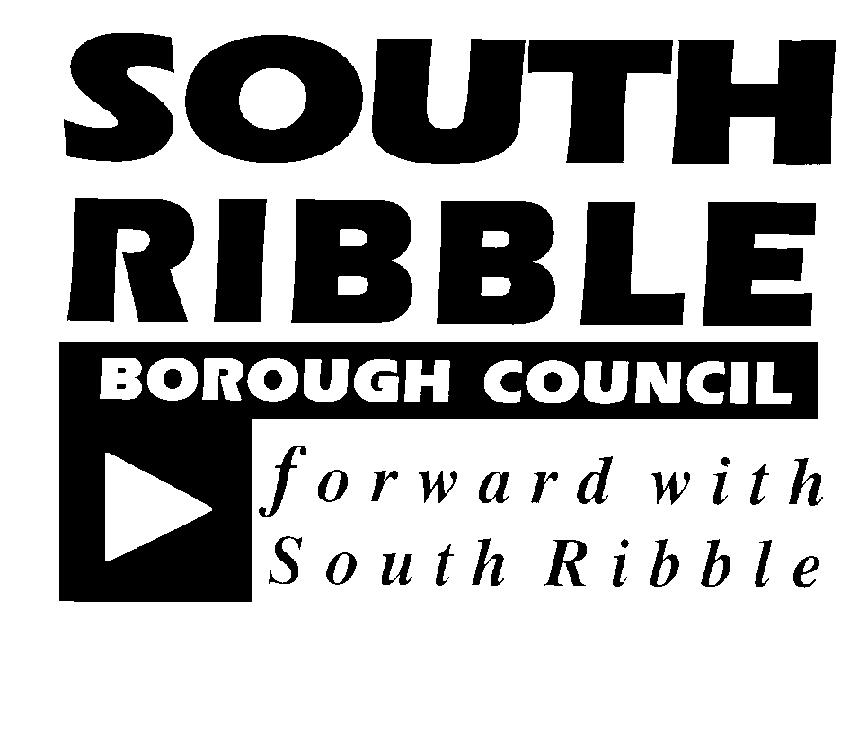

Standards Committee

Time/Date of Meeting: 6.00pm, Thursday 23 February 2017

Venue: Oaks Room, Civic Centre, West Paddock, Leyland, PR25 1DH.

Membership: Councillors Hesketh (Chairman), Bird, Evans, Higgins, Mrs S Jones, Wharton and Mrs Woollard and Mr B Parsonage (Independent Person)

Queries: Andy Houlker, Civic Centre, West Paddock, Leyland, PR25 1DH
Telephone: 01772 625308
Fax: 01772 625319
Text: 07776176981
E-mail: democraticservices@southribble.gov.uk

The minutes of this meeting will be available on the internet at www.southribble.gov.uk

AGENDA

 | 1 | Apologies for Absence
 | 2 | Declarations of Interest  Members are requested to indicate at this stage in the proceedings any items on the agenda in which they intend to declare an interest. Members are reminded that if the interest is a Disclosable Pecuniary Interest (as defined in the Members’ Code of Conduct) they must leave the room for the whole of that item. If the interest is not a Disclosable Pecuniary Interest, but is such that a member of the public could reasonably regard it as being so significant that it is likely that it would prejudice their judgment of the public interest (as explained in the Code of Conduct) then they may make representations, but then must leave the meeting for the remainder of the item.
 | 3 | Minutes of the Last Meeting  Held on Thursday 8 December 2016, to be signed as a correct record.
 | 4  5  6  7 | Social Media Protocol for Members  Report attached.  Progress Report  Report attached.  Code of Conduct for Elected Members – Review  Report attached.  Appointment of Second Independent Person  Report attached.
Forthcoming Meetings
6.00pm Thursday, 29 June, 2017 Cross Room, Civic Centre, West Paddock, Leyland PR25 1DH
6.00pm Thursday, 21 September, 2017 Oaks Room, Civic Centre, West Paddock, Leyland PR25 1DH
6.00pm Thursday, 7 December, 2017 Paddock Room, Civic Centre, West Paddock, Leyland PR25 1DH
6.00pm Thursday, 15 March, 2018 Cross Room, Civic Centre, West Paddock, Leyland PR25 1DH

